To: UTA Board of Directors and Carolyn Gonot, Executive Director
From: Bob Biles, Chief Financial Officer
Date: September 26th, 2019
Subject: UTA Reserves

During the recent 2020 budget discussions, the Board of Trustees asked for additional information about UTA’s projected reserves, especially the expected composition and use of unrestricted reserves.

Earlier this year, the Board of Trustees approved its Financial Management Policy No. 2.1 which, among other things, established required reserve levels for the General Operating, Service Stabilization, Bond, and Capital Replacement reserves and continued the use of the Debt Reduction reserve. These required reserves are taken into account as UTA staff updates the long-range financial forecast (“TFP”) as well as the annual budget. As shown in the chart below, July 2019 TFP projections show that the ending balance at the end of each fiscal year exceed the required reserves by the amounts listed on the “Designated/Unrestricted” line.

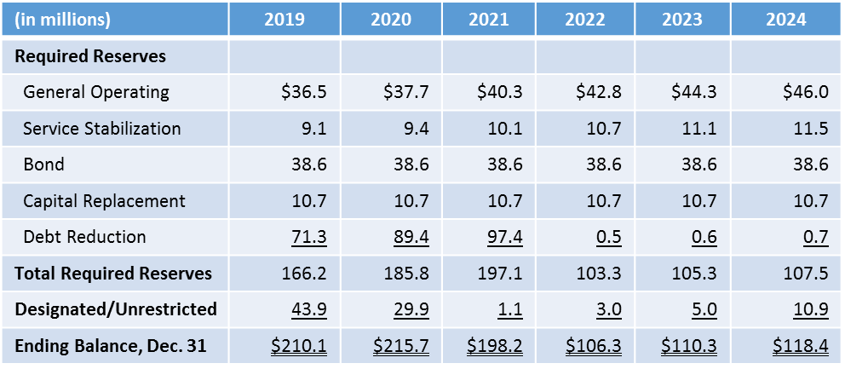

For 2019 and 2020, the Designated/Unrestricted amounts represent planned spending for capital projects. Please see the chart below for the intended uses of the Designated/Unrestricted amounts for those years.

 | 2019 | 2020
2018 Bond Proceeds | $18,550,000 | $ 5,550,000
2020 Bond Proceeds |  | 13,180,000
Designated for capital projects in subsequent year | 25,050,000 | 11,170,000
Designated/Unrestricted | $43,900,000 | $29,900,000

Please let me know if you need any additional information.

